**Adit Biosciences Website**

**User Manual**

# Table of Contents

1. Introduction 3
2. Guide to Django Admin Interface for the website 3

2.1 Adding/Deleting an interface user. 4

2.2 Changing the password. 5

2.3 Adding/Deleting/Editing a post in Farmer’s Education section of the website. 5

2.4 Adding/Deleting/Editing a post in the News section of the website. 8

2.5 Adding/Deleting/Editing a post in FAQ section of the website. 8

2.6 Replying to a comment in the ‘Disqus’ forum of the website with ‘Mod’ tag. 8

## Introduction:

This manual describes the Adit Biosciences Web Site. The website provides a simple, open-source, easy method of building and maintaining web sites consisting of multiple pages of information. The programming was designed for ease of maintenance, so the information the source code requires to process a page is mainly stored in the name of the page itself.

The web site template and source code are built from the python-based web framework Django along with some off the shelf third-party programs Django admin interface, disqus to operate, and should run on any standard browser, anywhere without any need to access any third-party software.

## Guide to Django Admin Interface for the website:

The site was developed with python-based web framework Django, so to use any functionalities provided by the website for admin-based work has to be done through the online Django admin interface.

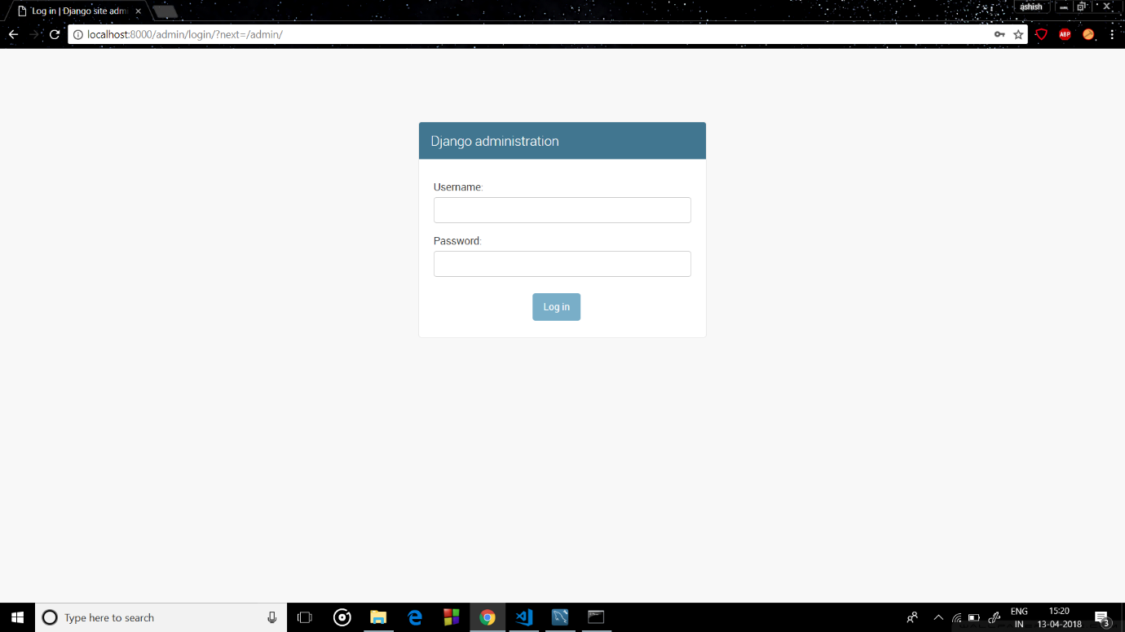

Upon accessing the Django admin interface, the user will be asked for the username and password to login as the administrator of the website. These login credentials are provided to the client at the time of delivery of the end product.

Once logged in the admin will be able to use the following functionalities of the website:

2.1Adding/Deleting an interface user.

2.2 Changing the password.

2.3 Adding/Deleting/Editing a post in Farmer’s Education section of the website.

2.4 Adding/Deleting/Editing a post in the News section of the website.

2.5 Adding/Deleting/Editing a post in FAQ section of the website.

2.6 Replying to a comment in the ‘Disqus’ forum of the website with ‘Mod’ tag

### Adding/Deleting an interface user:

The receiver of the end product can allow any person to access the website with admin privileges by adding him to the users list in the Django admin interface as shown below.

He can also remove any pre-existing user from here too.

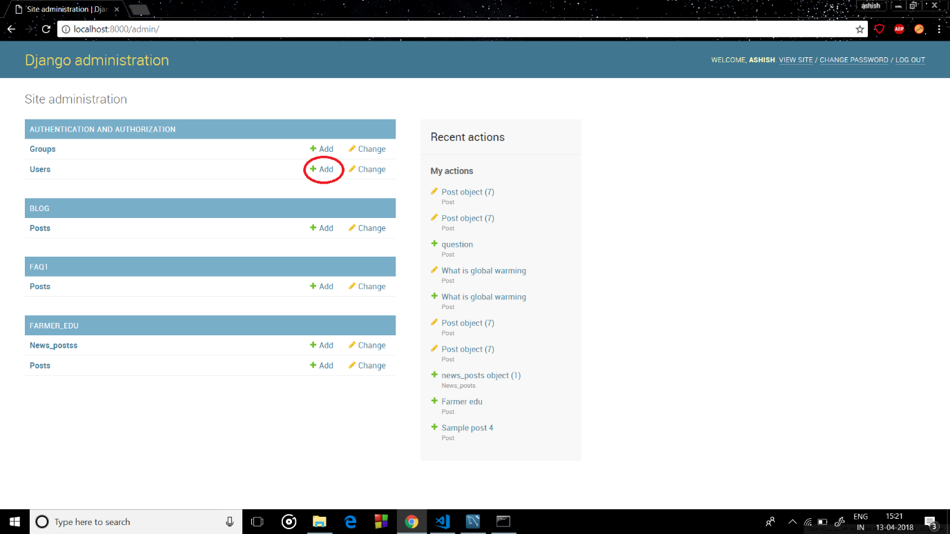

### Changing Your password:

The user can change the password for the Django admin interface by clicking on the ‘Change Password’ link provided in the home screen of Django admin interface as shown below.

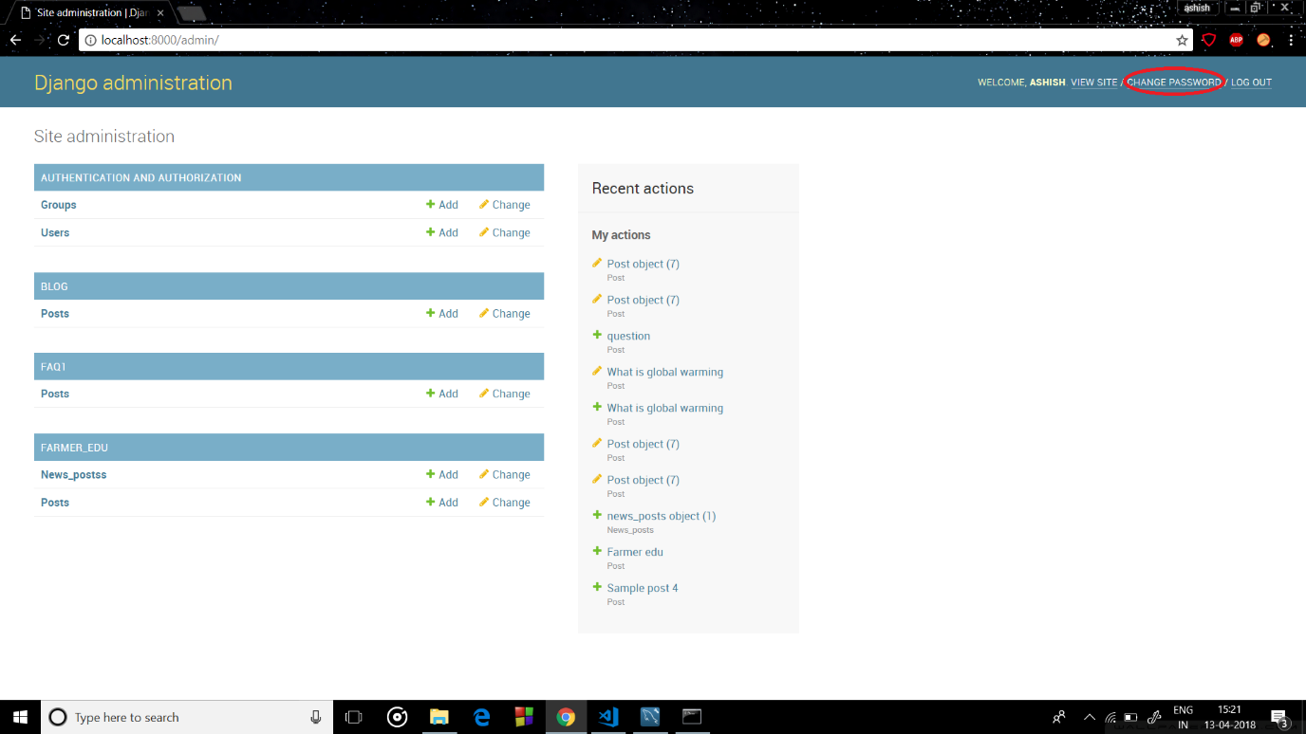

### Adding/Deleting/Editing a post in Farmer’s Education section of the website:

Once logged in to the Django interface the user can see the Farmer’s Education section of the database. Here there is a record of previous posts made in the section. The post consists of a title and the detailed contents of the post.

To add a new post to the Farmer’s Education section of the webpage, click on the add post button provided. This will open up a new page which will ask the user to input the title of the post and the detailed contents of the post. Both of these are necessary to fill. See the following screenshots for more information.

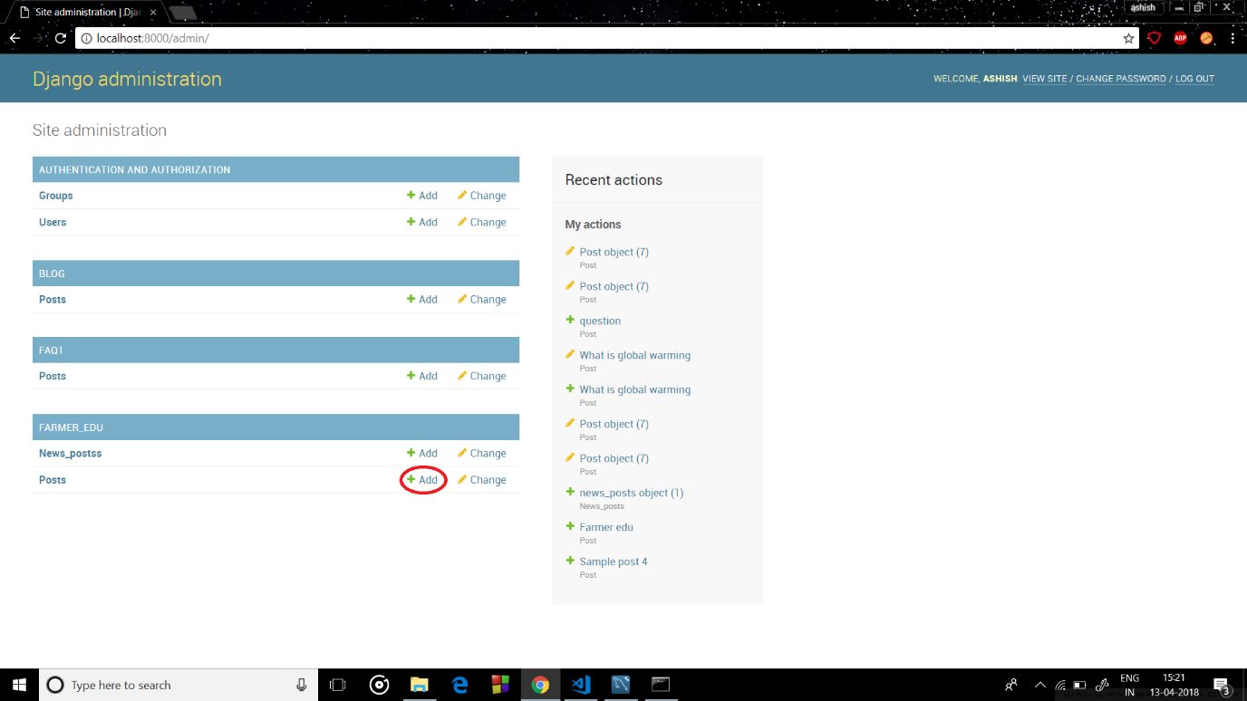

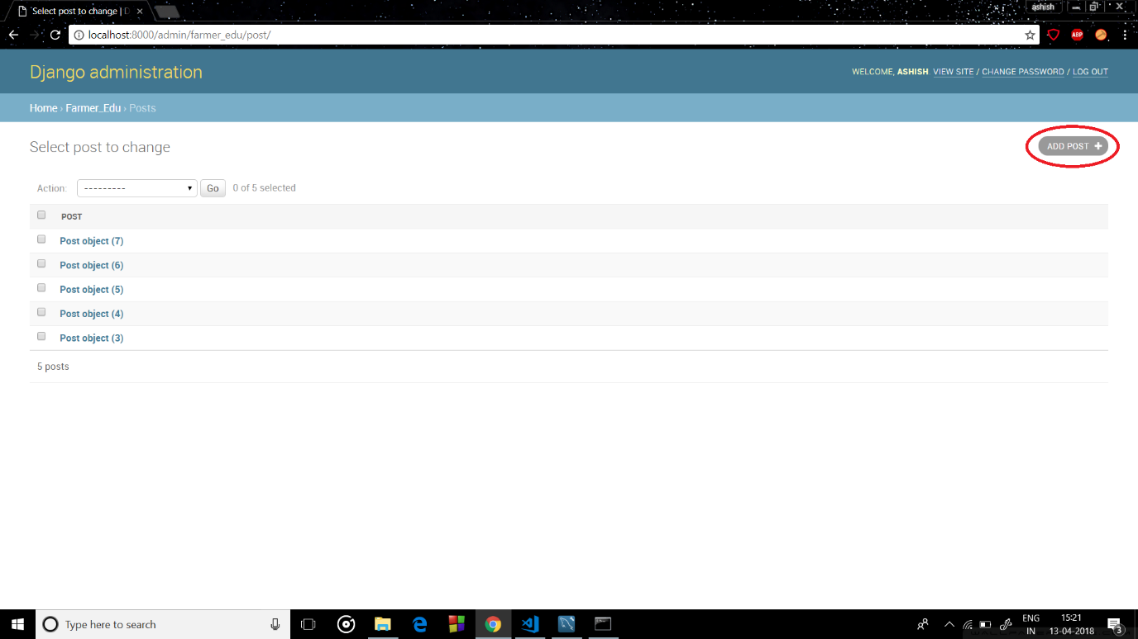

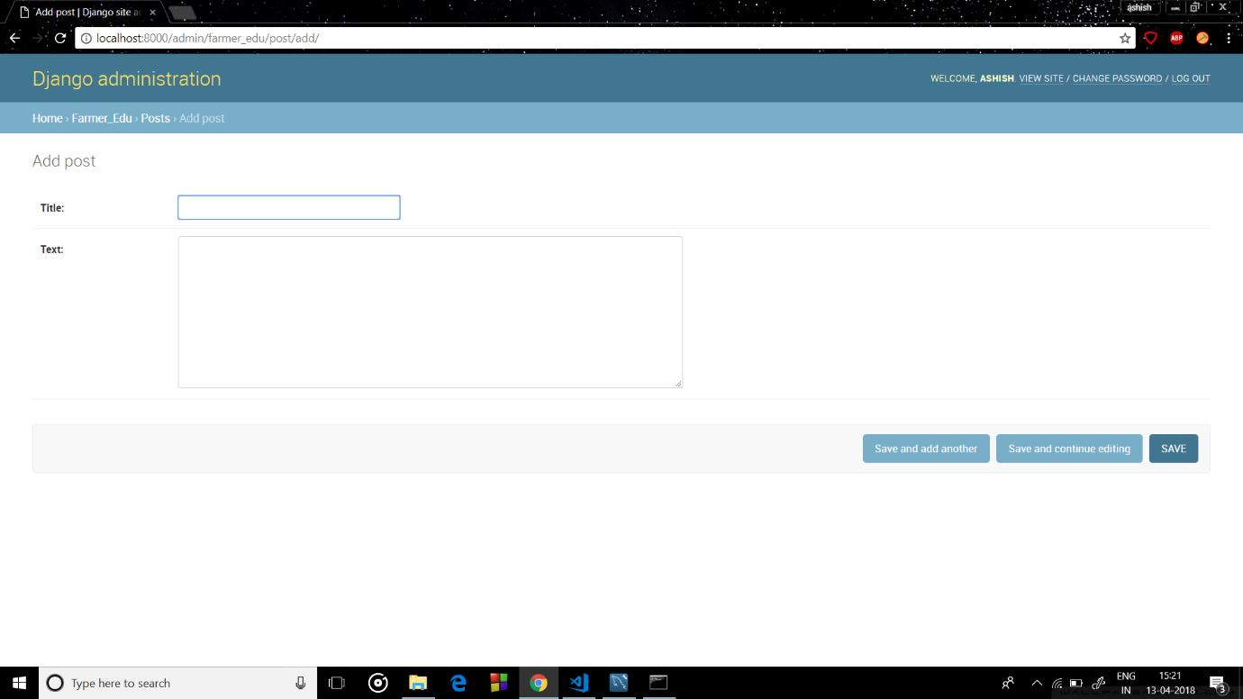

Once done with the above step click on one of the three Save buttons provided below the entry fields as per your convenience to add the new post to the website.

The user can also delete any pre-existing post by selecting the delete option from the drop-down menu shown below.

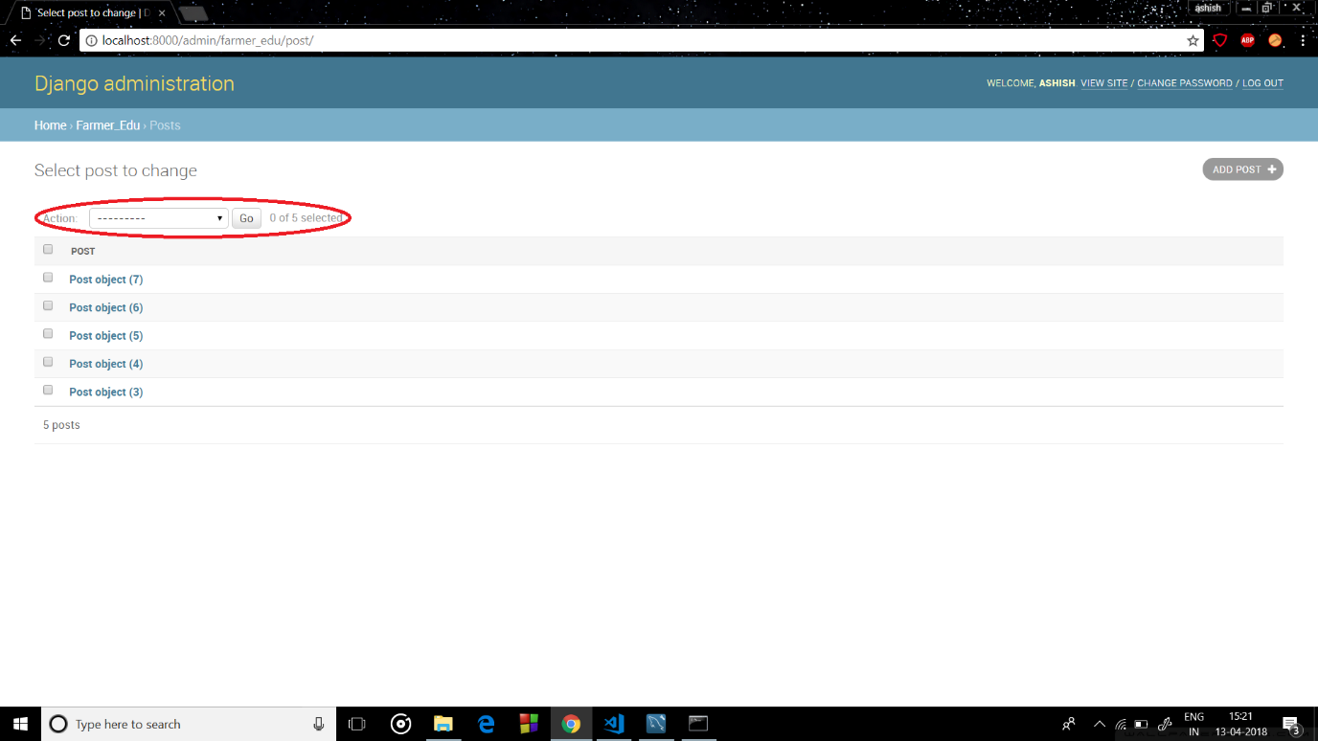

The user can also edit any pre-existing post by selecting the edit option from the same drop down menu or by clicking the post itself. Upon doing so will open the page consisting of the information filled during the creation of the post which the user can edit to his heart’s content.

### 2.4 Adding/Deleting/Editing a post in News section of the website:

Once logged in to the Django interface the user can see the News section of the database. Here there is a record of previous posts made in the section. The post consists of a title and the detailed contents of the post.

To add a new post to the News section of the webpage, click on the add post button provided. This will open up a new page which will ask the user to input the title of the post and the detailed contents of the post. Both of these are necessary to fill. The steps for doing these are the same as

Once done with the above step click on one of the three Save buttons provided below the entry fields as per your convenience to add the new post to the website.

The steps to delete/edit an existing post is also the same as that of the Farmer’s education section one.

### 2.5 Adding/Deleting/Editing a post in FAQ section of the website:

Once logged in to the Django interface the user can see the FAQ section of the database. Here there is a record of previous posts made in the section. The post consists of a question which the user thinks to be a frequently asked question asked by the viewers of the website and its appropriate response as per the user’s understanding.

To add a new post to the FAQ section of the webpage, click on the add post button provided. This will open up a new page which will ask the user to input the title of the post and the detailed contents of the post. Both of these are necessary to fill. See the following screenshots for more information.

Once done with the above step click on one of the three Save buttons provided below the entry fields as per your convenience to add the new question to the website.

The steps to delete/edit an existing question is also the same as that of the Farmer’s education section one.

### 2.6 Replying to a comment in the ‘Disqus’ Forum with a ‘Mod’ tag:

After logging in, the user can reply to any comments in the ‘Disqus’ forum attached in each relevant section of the website like Farmer’s Education, News etc. Upon doing so a tag of moderator or ‘Mod’ will be attached to his reply which will ensure the viewers of the website that the reply is an authentic reply from the members of Adit Biosciences company.